

CAD-parametric optimization with optiSLang-ANSYS workbench

Andreas Veiz1* & Markus Egerland2

## 1 University of Applied Sciences Jena, Jena, Germany

**2 SiemensVDO automotive AG, electric motor drives, Würzburg, Germany**

**Summary**

The handling of geometric parameters from CAD files to get a high level of automization in FE analyses, particularly with regard to optimization processes is a contemporary issue for engineers.

Preferable is the direct use of CAD data without further intervention of the user. But the automatic parameter optimization process based on CAD/FEM models poses special requirements, not only a reliable geometry interface.

Subject of this paper is to show the ability of the software tools optiSLang and ANSYS workbench to handle geometric parameters based on ProEngineer CAD models. Two different kinds of failures possibly occur in an automatic parametric optimization process before the FE analysis can start:

1. The CAD program is not able to regenerate the parameter modified model.
2. The CAD program regenerates the model, but the mesh algorithm of ANSYS workbench is not able to create a mesh.

Furthermore not only the pure ability to mesh, but also the quality and quantity of the elements is to be regarded. Therefore, sometimes the direct use of parametric CAD models is not manageable for any optimization task by now.

Three different workflows will be presented:

* 1. Direct use of CAD model via ANSYS/ProE interface without interaction.
  2. Use of CAD model with suitable geometric preparation in workbench DesignModeler.
  3. Complete new generation of the CAD model with DesignModeler to create an accurate FEM model.

**Keywords:** CAD parameter based optimization, model requirements, geometry regeneration, FEM-compatible preparation, meshing.

* Contact: Andreas Veiz, DYNARDO – Dynamic Software and Engineering GmbH, Luther- gasse 1d, D-99423 Weimar, E-Mail: [andreas.veiz@dynardo.de](mailto:andreas.veiz@dynardo.de)

# Requirements of automatic parametric optimization

For automatic parametric optimization a model consisting of a CAD geometry and a FEM model has to be created. Both, the CAD model as well as the FEM model can cause difficulties for the parametric optimization process.

## CAD geometry

Particularly CAD models with a high number of geometric parameters require special diligence to get accurate results.

Fig.1 shows an example with a high amount of possible geometric parameters where regeneration failures easily occur, if the user not takes account of some issues.

At first the user should avoid regeneration failures due to overlapping contours. As an example in Fig. 1 the location and width of ribs is a possible parameter.

The probability of overlapping contours increases with the number of ribs which are moved on the surface.

A further reason for overlapping is the variation of curves and angles.

To avoid this kind of regeneration failure either the parameter range has to be limited or the user has to control the variation by relations between the parameters.

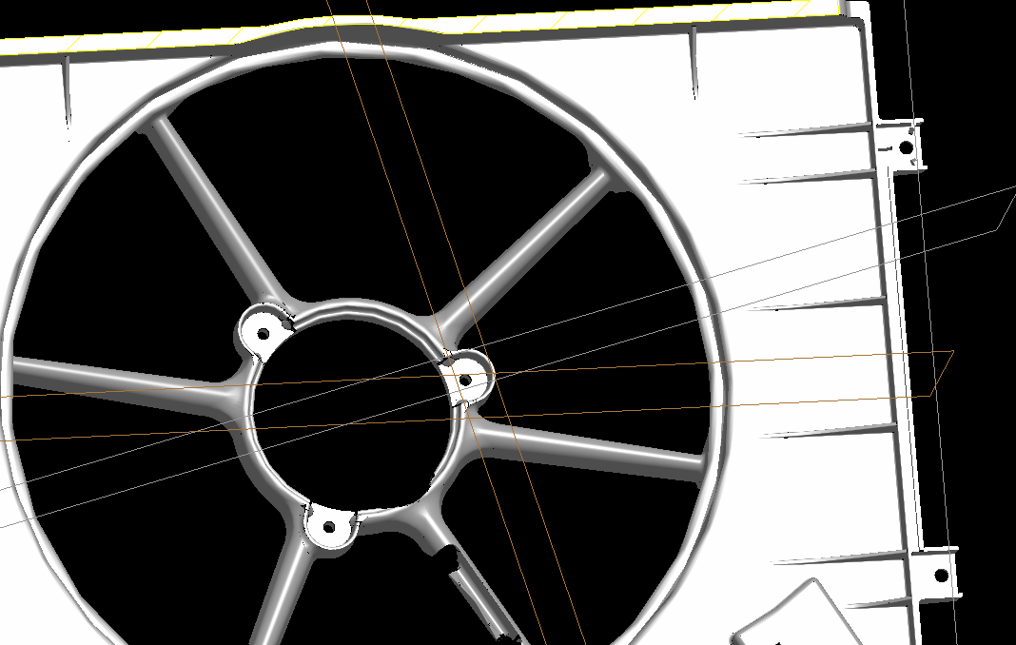

Fig.1:

CAD model of a fan shroud with a high number of geometric parameters.

But before relations between parameters can be defined, the user has to identify every parameter. This is an often underestimated task, if the user and the creator

of the CAD model are not identical. Especially for big amounts of parameters this is hardly to manage.

Before a CAD based optimization can be started, the user has to distinguish between dependent and independent parameters.

Relations between parameters must be known, in typical CAD models some geometric properties are driven by references. Even moderate changes of parameter values increase the probability of regeneration failures, if dependent parameters are not defined.

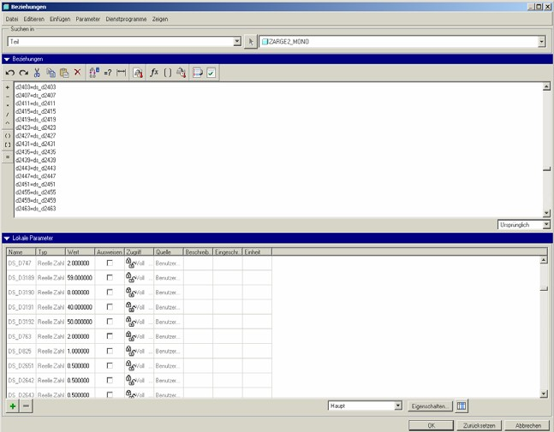

Fig.2: ProE parameter manager

This task can be done within the ProE parameter manager (Fig.2) as well as by using the ANSYS DesignModeler parameter manager.

Clearly arranged parameters with reasonable terms are useful but also hardly to manage for extensive models.

This points to the benefit of a close communication with the CAD designer.

## FE-model: accurate meshing

The Mesh for the optimization task has to meet four different requirements:

1. Automated meshing must be possible for changing edges,angles and surfaces.
2. The mesh quality must be comparable for every parameter combination
3. Accurate results for changing of the geometry, with respect to thin structures.
4. In ligth of the expected number of calculations the calculation time should not be to long.

Concerning the topics 1 to 3 it is obviously, that the meshing requirements for an optimization task are more demanding as for a single FEA.

In combination with a complex CAD geometry as shown in Fig.3, which includes features with very small edges and surfaces (Fig.4), the needed number of finite elements is a limiting value for the use of original CAD models without suitable modifications.

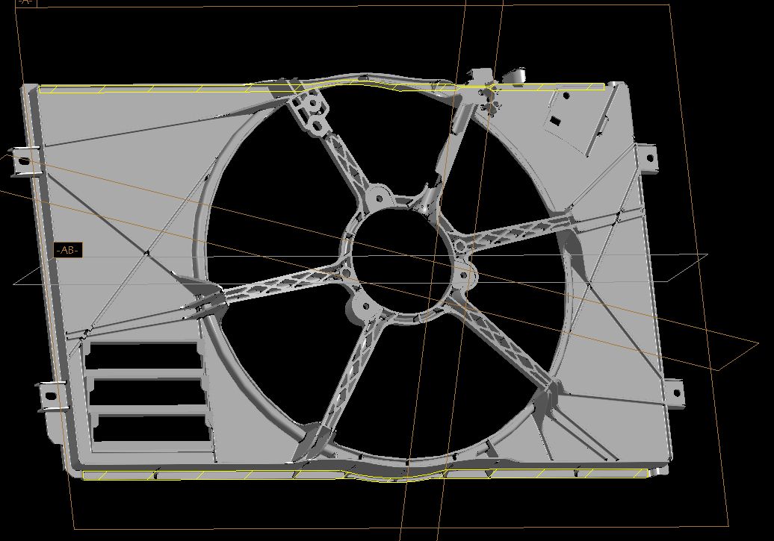

Fig.3:

Original ProE model (automotive fan shroud) without modifications.

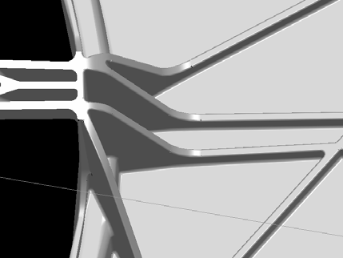

Fig.4:

Original CAD model includes small rounding on each rib.

The following examples will show how CAD - parametric optimization is manageable with the help of the ANSYS workbench environment, including the DesignModeler.

# Direct use of CAD model via ANSYS/ProE interface without interaction.

To present how the direct use of a parametric CAD model with usage of the existing ANSYS/ProE interface works, the model shown in Fig.5 was generated. It is an analogous model for sheet metal applications, which are used for oil pans or other deep-drawn components.

Fig.5:

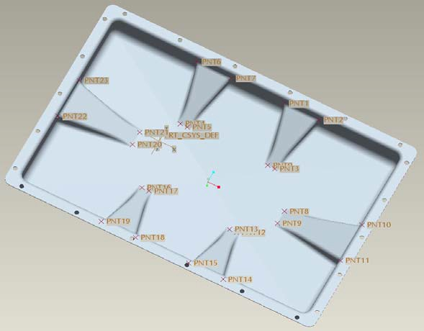

ProE model including skeleton construction and references.

The model (Fig.5) was provided with reference points and axes to show the ability of optiSLang and ANSYS to handle a reference driven CAD geometry.

Since the CAD parameters are directly connected with the ANSYS parameter manager (Fig.6), changes of them cause immediate geometry variations.

As argued before, the user has to validate now an accurate FE mesh.

Fig.6:

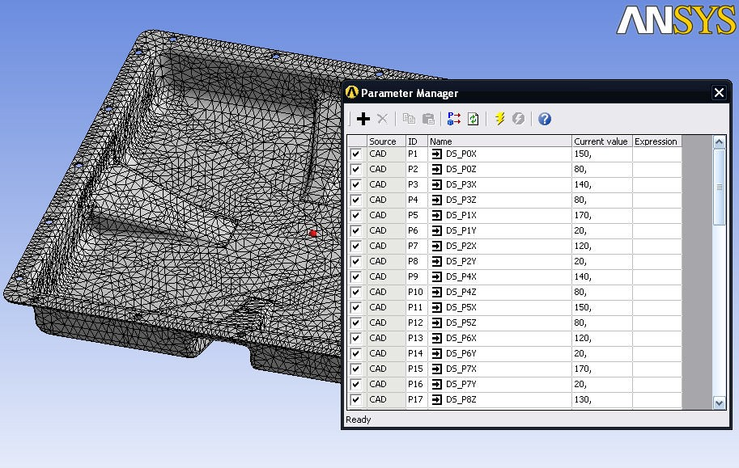

FEA model within ANSYS Worbench with list of active parameters.

For this example, where the CAD designer and the FE user are identical, a significant number of parameters were successful applied for the optimization with optiSLang.

But some hints should be taken into account.

The used references should be set as simple as possible, to facilitate the identification of parameter relationships. The general requirements for CAD based automatic parametric optimization, like avoiding overlapping contours are valid as well.

Be aware that on complex geometries the references may fail when the values of the parameters are changed.

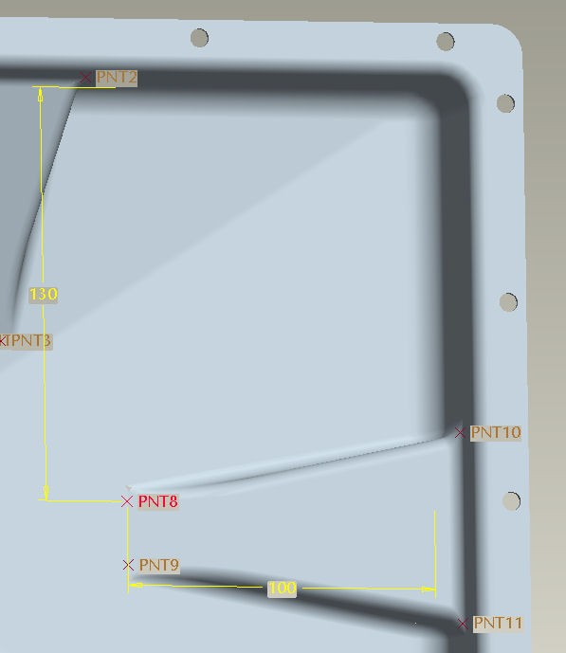

Fig.7:

Parameters in reference to construction points.

Benefits of a direct Interface:

* The parameters are directly linked to the CAD-geometry.
* Each changing of a parameter value causes an immediate changing of the geometry.
* The best design can be extracted directly to the CAD System.

Problems with a direct Interface:

* Usually, a CAD model is not designed for optimization.
* The CAD model has to be accurate to avoid meshing problems.
* Bad geometry in original CAD model or due to interface can cause generation failures.
* Meaning of every parameter has to be identified

# Use of CAD model with suitable preparation in workbench DesignModeler.

For this example a ProE model of a bearing shield used in serial-production was prepared with the workbench DesignModeler for an optimization with optiSLang. The original CAD geometry is read into the ANSYS DesignModeler using the CAD interface (Pro Engineer).

The workbench DesignModeler is able to identify the CAD parameters, the user has to decide which parameters should be active for the optimization.

Within the DesignModeler reasonable simplifications can be done in view to an effective meshing.

Thereby the DesignModeler parameter Manager is useful to define some necessary relations between original CAD parameters and parameters generated by DesignModeler (Fig.8).

Fig.8:

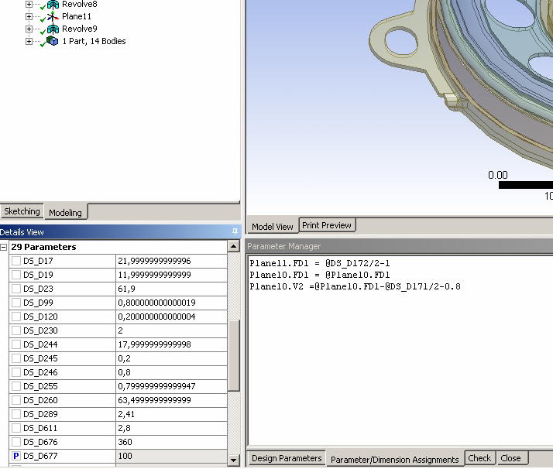

DesignModeler parameter manager with simple relations between active parameters.

For an effective FE-mesh the ANSYS DesignModeler provides several needful features.

The geometric body can be sliced, curvatures and edges can be deleted, openings can be filled.

In this example the model was divided into different parts by slicing and defined as a single part to get a merged FE mesh.

The geometry shown in Fig.9 was generated and transferred into the workbench simulation environment.

The ANSYS mesh algorithm was able to generate a FE mesh with hexahedrons for the most important parts, only the two mounting plates were meshed with tetrahedrons.

The FE mesh (Fig.10) was very stable during the optimization with optiSLang and provided accurate results.

Fig.9:

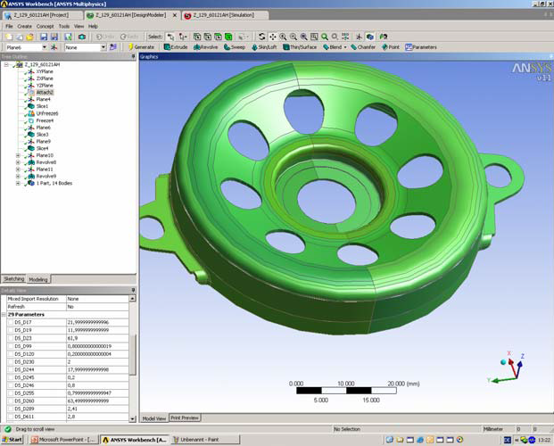

ANSYS DesignModeler: Modified ProE model.

Fig.10:

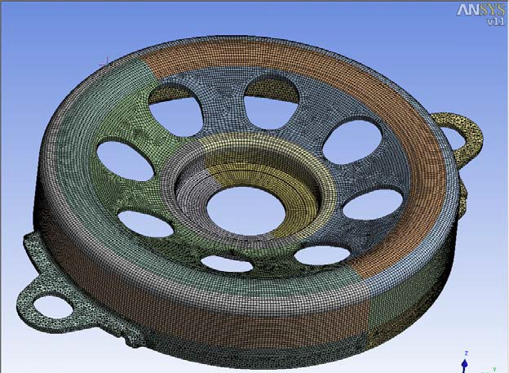

FEA model within ANSYS workbench environment.

Benefits of CAD interface + FEM applicable simplifications:

* Active parameters are directly linked to CAD system.
* Better applicable model for accurate meshing.
* Optimized design can be generated in CAD system via optiSLang plugin.

Problems of CAD interface + FEM applicable simplifications:

* Additional amount of work is necessary.
* Too many simplifications can produce parameter conflicts.
* Bad geometry in original CAD model or due to interface can cause generation failures.
* Meaning of every parameter has to be identified

# Complete new generation of the CAD model with DesignModeler to create an accurate FEM model.

To test the ability of the combination optiSLang/ANSYS to handle a significant number of parameters a fan shroud was chosen like in the fan module shown before (Fig.1,3,4). Within the original model more than 2000 parameters may be found, some of them in used references or the skeleton construction. At all this situation causes regeneration failures. With the DesignModeler a simplified CAD model was generated and parametrized with the most significant parameters. To avoid regeneration failures mathematical relations were created between some parameters. This is possible with the DesignModeler parameter manager (Fig.11).

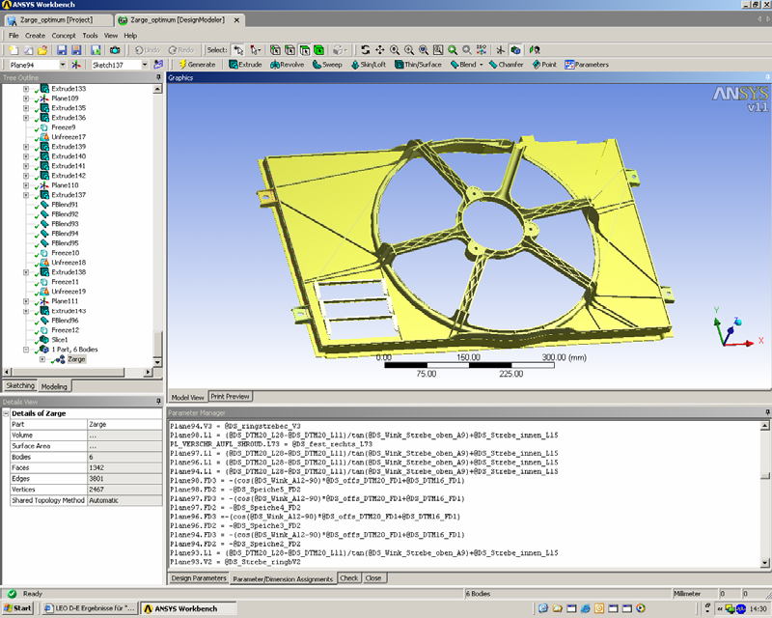

Fig.11:

Simplified CAD model generated with DesignModeler.

At the end 94 parameters were used for the optimization with optiSLang (Fig.12). With the complete new model designed just for the optimization task, this number of parameters was manageable.

The FE mesh shown in Fig.13 consists of about 35000 elements. This seems to be an extremely fine mesh, but in view of the specific requirements for an optimization task and the thin structures in this object the time and effort is justifiable.

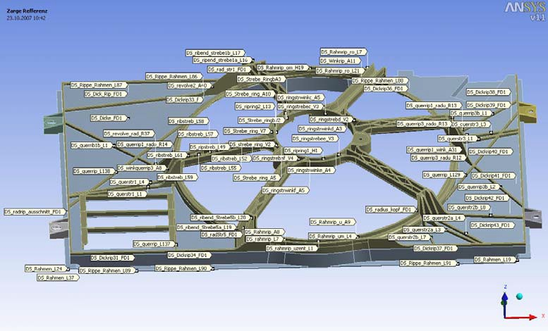

Fig.12:

Model with parameter locations.

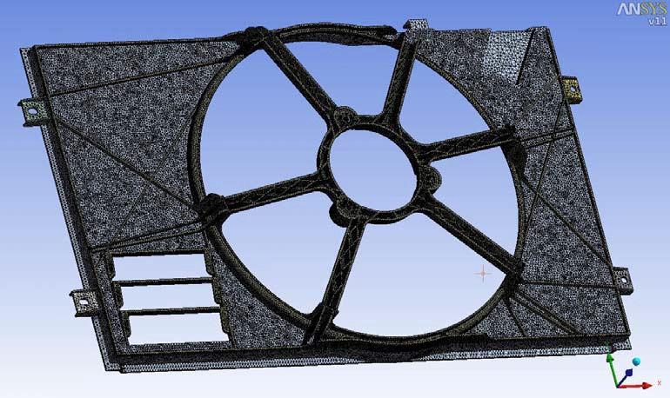

Fig.13:

FEA model with accurate mesh.

Regarding this big amount of elements in this simplified model everyone can imagine how expensive the FE mesh in the original CAD model would be.

With optiSLang a sensitivity analysis, an ARSM within the reduced parameter space and an EA optimization (Fig.14) were performed.

At the end a robustness analysis confirmed the results.

At least a mass reduction of the fan shroud which is in use in automotive applications of nearly 15% was reached.

Fig.14:

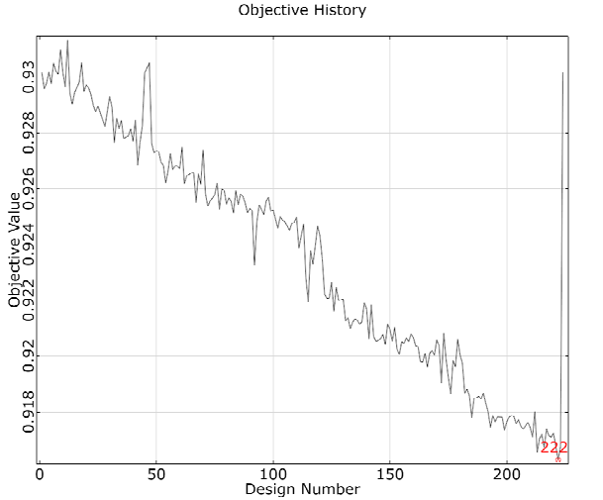

Objective history of EA optimization with OptiSLang.

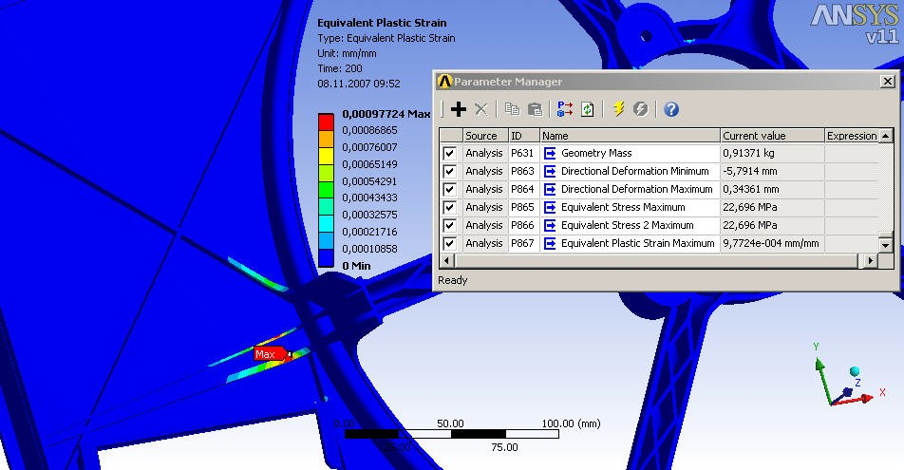

Fig.15:

Location of maximum equivalent plastic strain.

Benefits of complete new geometry model:

* A result can be achieved for complicated geometries with a high amount of parameters.
* Geometry can be modeled with regard to accurate meshing.
* User has control and general idea about parameters.

Problems of complete new geometry model:

* Much work for the model generation is necessary.

# Conclusions

Three approaches for parametric optimization based on CAD geometries are presented:

Every procedure has benefits and handicaps.

1. Direct use of CAD model via ANSYS/ProE interface without interaction:

Recommendable for CAD models parameters without meshing problems.

with a manageable amount of

1. CAD interface + FEM applicable simplifications:

Recommendable for CAD models

with a manageable amount of

parameters meshing and geometrical generation problems can be cleared.

1. Complete new geometric model:

Recommendable for extremely complicated geometries with a big amount of parameters.

The use of CAD Models depends on the complexity of the geometry. At least a close communication with the CAD designer is necessary.

To get accurate results finite element knowledge is necessary.

# References

[1] Release 10.0 Documentation for ANSYS workbench

[2]

Release 11.0 Documentation for ANSYS workbench

[3] optiSLang documentation version 2.1